

SIMATS ENGINEERING

Saveetha Institute of Medical and Technical Sciences Chennai- 602105

Student Name: Moniga V Reg. No.:192521184
Course Code: CSA0315 Slot: D
Course Name: Data Structures

Course Faculty: Dr. T Rajesh Kumar

Project Title:
Hospital Appointment Booking Using Queue Data Structure
Module Photographs: (3 photographs –Module Photo, Individual student contribution module work in the project and presentation image)
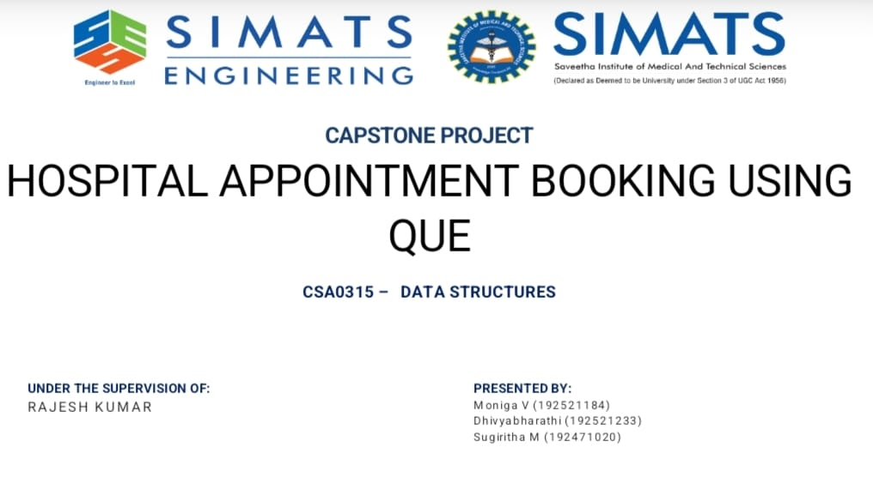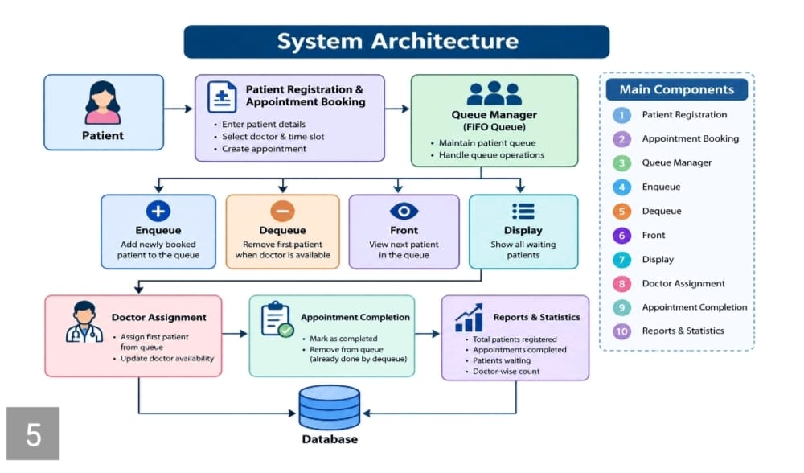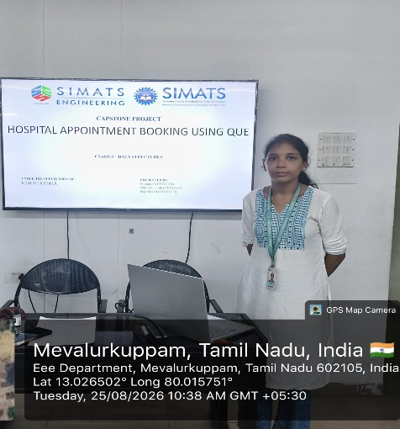
Project Description: (here you write what you did in this project (contribution) including Model Description
The Hospital Appointment Booking System Using Queue Data Structure is a system designed to efficiently manage patient appointments in a hospital. Patients can register and book appointments with doctors, and their requests are added to a queue based on their order of arrival. The system follows the FIFO (First In, First Out) principle, ensuring that patients are attended to fairly and systematically. When a doctor attends to a patient, the patient is removed from the queue using the dequeue operation. The system can also display the current waiting list and appointment status of patients. This project helps reduce manual work, waiting-time confusion, and errors while demonstrating the practical use of the Queue data structure in real-world healthcare management.

Student Signature Guide Signature

